**Assignment 1**

**Task 1**

Task 1 took approximately 13 minutes

*Spark History*

**Output:**

('11DC93DD66D8A9A3DD9223122CF99EFD', 352),

('EE06BD8A621CAC3B608ACFDF0585A76A', 348),

('6C1132EF70BC0A7DB02174592F9A64A1', 341),

('A10A65AFD9F401BF3BDB79C84D3549E7', 340),

('23DB792D3F7EBA03004E470B684F2738', 339),

('7DA8DF1E4414F81EBD3A0140073B2630', 337),

('0318F7BBB8FF48688698F04016E67F49', 335),

('B07944BF31699A169091D2B16597A4A9', 334),

('738A62EEE9EC371689751A864C5EF811', 333),

('7D93E7FC4A7E4615A34B8286D92FF57F', 333)]

**Task 2**

Task 2 took approximately 25 minutes

*Spark History*

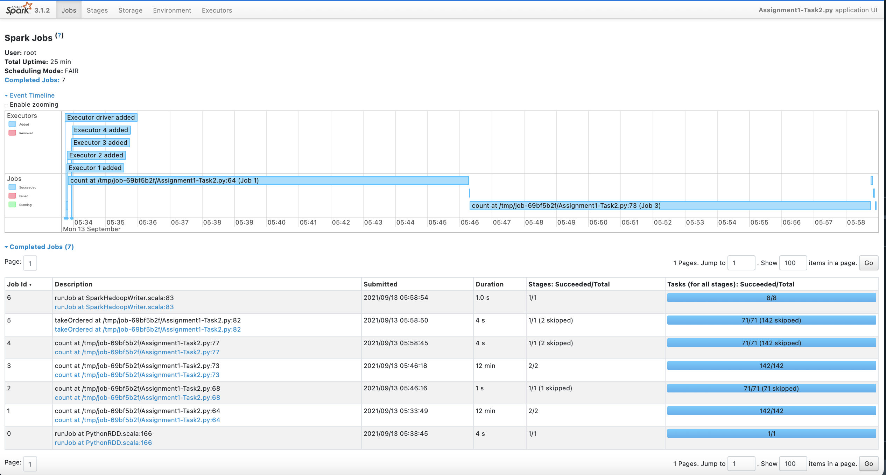

Output

‘E35D5869A2E09FFD1DE28C70D1D2E385',

'ECA1B12A5C8EA203D4FE74D11D0BF881',

'47E338B3C082945EFF04DE6D65915ADE',

'5616060FB8AE85D93F334E7267307664',

'6734FA703F6633AB896EECBDFAD8953A',

'D67D8AB4F4C10BF22AA353E27879133C',

'197636D970408B80F9A7736769BF548A',

'15D8CAECB77542F0F9EE79C4F59D7A3B',

'E4F99C9ABE9861F18BCD38BC63D007A9',

'6DE82A3D99C7935637ADC1AEA6430F52'